OBJECT DETECTION MODEL COMPARISON

Models Evaluated
- YOLOE
- Grounding DINO
- OWL-ViT

Evaluation Metrics
- Detection Rate
% of frames where object is correctly detected
- Confidence Score
Model certainty per detection
- Processing Time
Average runtime per frame
- Qualitative Analysis
Missed detections
False positives
Detection behavior

Dataset
- Simulated data
- Real-world data

Results – Simulated Data

Setup
- Task: boilWater-1
- Frames: 27
- Objects: pot, sink
- Thresholds:
  - YOLOE: 0.3
  - Grounding DINO: 0.4
  - OWL-ViT: 0.1
- Prompt variations:
“metal pot” / “cooking pot” / “saucepan” / “container”
“sink” / “kitchen sink” / “sink basin” / “wash basin”

Key Findings
- Grounding DINO
  - Best performance overall
  - Pot: 88.89% detection, 0.826 confidence
  - Sink: 100% detection (with “wash basin”)
  - Strong robustness to wording changes
- YOLOE
  - Fast (~0.53 sec/frame)
  - Weak open-vocabulary flexibility
  - Works only with precise wording
- OWL-ViT
  - Weak performance overall

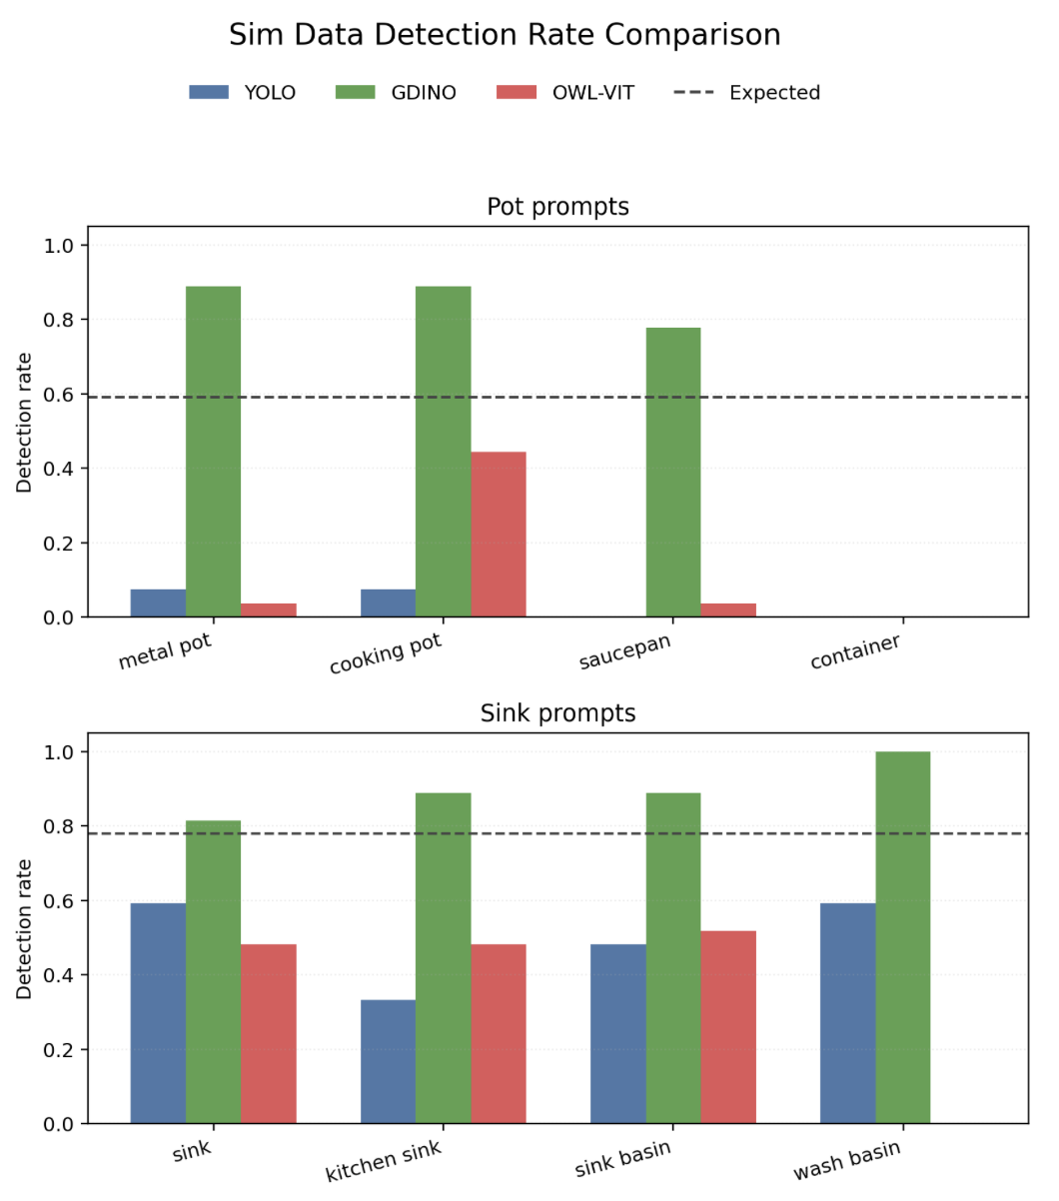

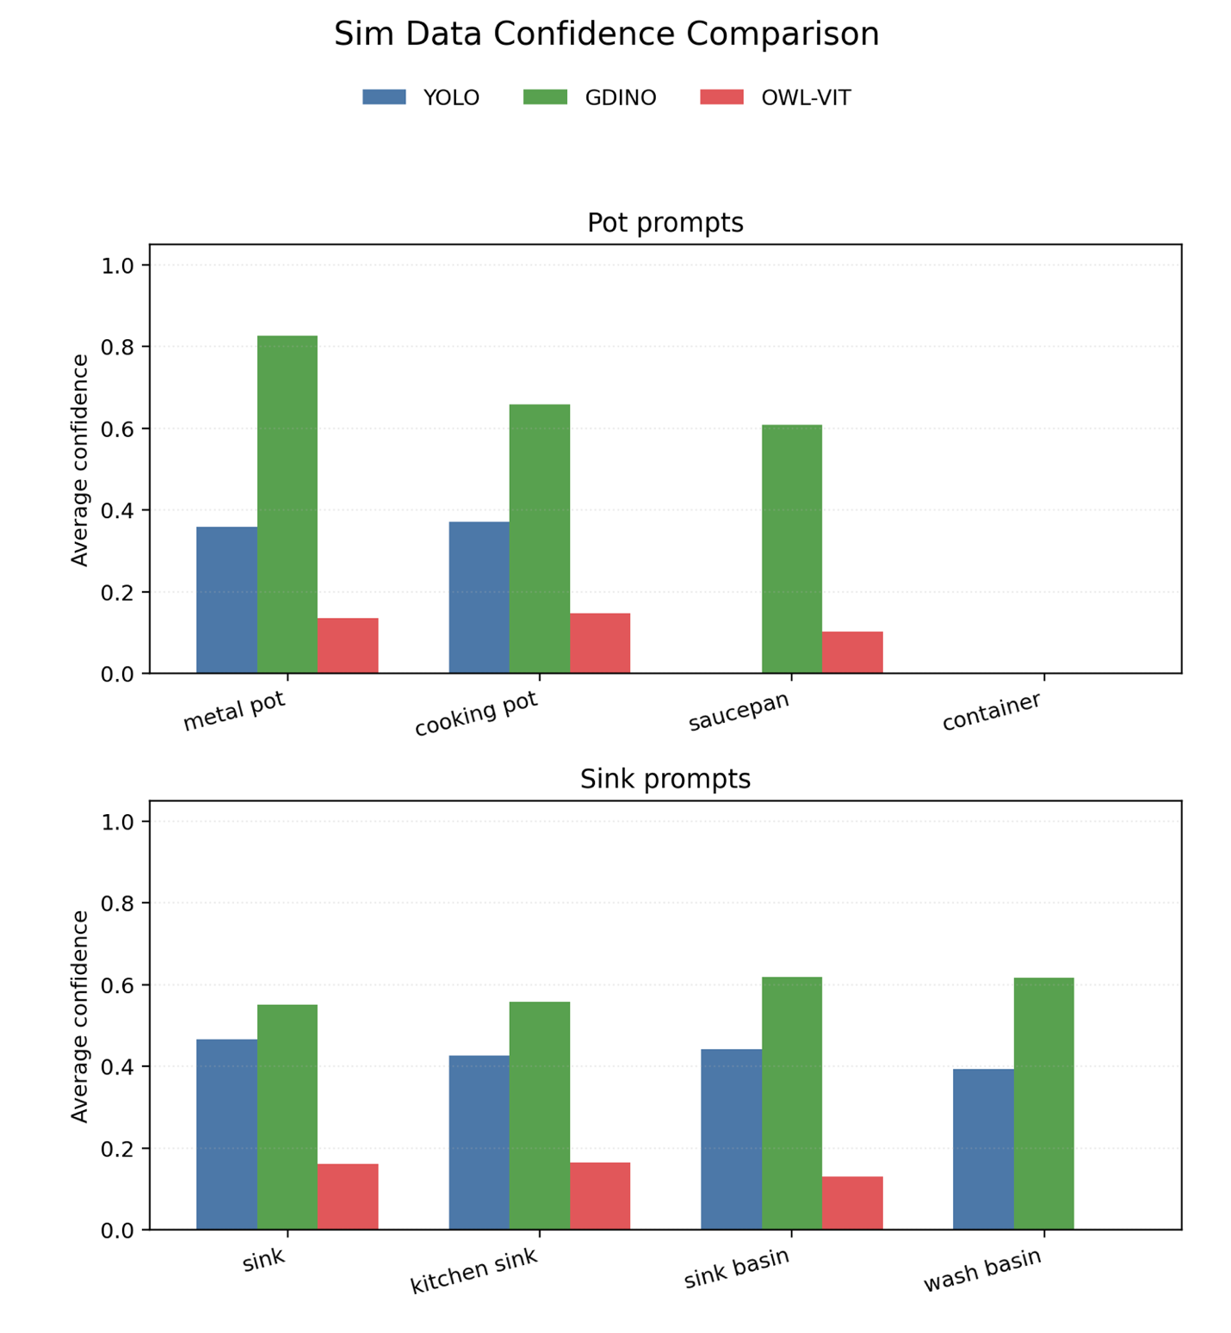

Results – Real-World Data

Setup
- Task: PutAppleBowl2
- Frames: 16
- Objects: “apple”, “bowl”
- Thresholds:
  - YOLOE: 0.3
  - Grounding DINO: 0.4
  - OWL-ViT: 0.1
- Prompt variations:
“apple” / “red apple” / “apple on the counter” / “fruit”
“bowl” / “dark blue bowl” / “dark blue bowl on the counter” / “container”

Key Findings
- Grounding DINO
  - Highest detection rate and flexibility
  - Detects “apple” as “fruit”
  - False positive:
    - Robot arm misclassified as apple in one frame (confidence 0.41)
- YOLOE
  - Lower detection rate
  - Performs better on bowl than apple
  - Sensitive to prompt wording
  - Threshold tuning → minimal improvement
- OWL-ViT
  - Very poor detection performance
  - Unreliable even with low threshold

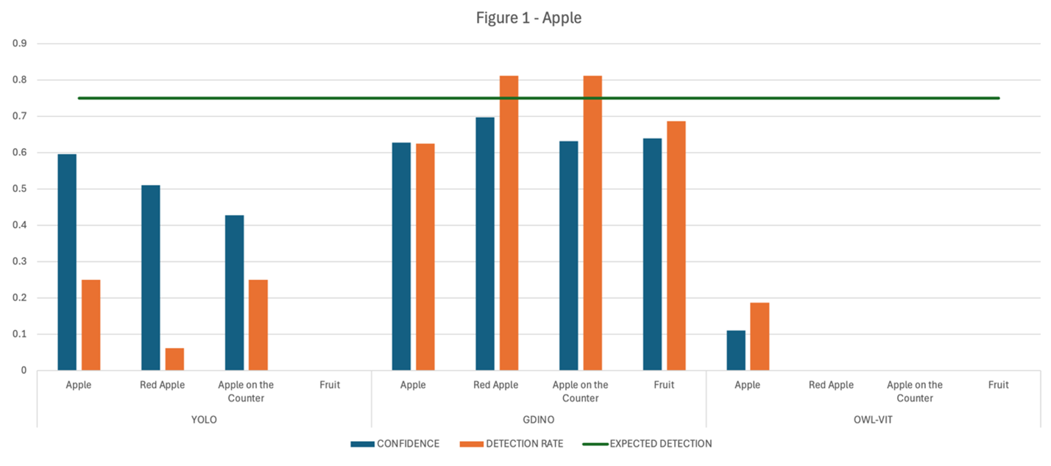
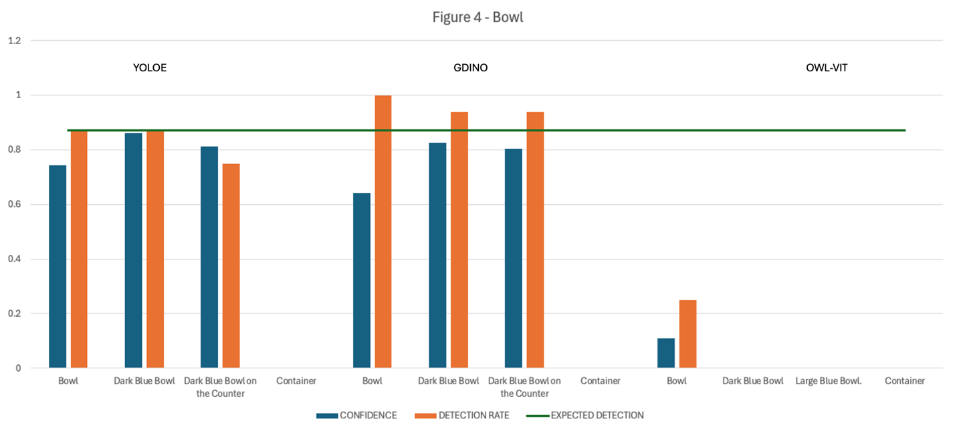

Important Observations
- High detection rate ≠ always reliable
  - (can be inflated by false positives)
- Some prompts (e.g., “container”) fail for all models
- Grounding Dino is the slowest at processing.

